**Assignment -1**

Registration Page Assignment

|  |  |
| --- | --- |
| Assignment Date | 19 September 2022 |
| Student Name | S.Dineshwaran |
| Student Roll Number | 621319104014 |
| Maximum Marks | 2 Marks |

**Question-1:**

Create registration page in html with username, email, and phone number and by using POST method display it in next html page.

|  |
| --- |
| **Solution:** |
| index.html |
|  |
|  |
|  |
|  |
|  |
|  |
|  |
| <!DOCTYPE html>  <html>  <head>  <meta charset="utf-8">  <meta name="viewport" content="width=device-width, initial-scale=1">  <title>Registration</title>  </head>  <body>  <center>  <br><br>  <h1>Registration</h1><br>  <form action="{{ url_for('result') }}" method="post">  <table>  <tr>  <td>  <label>Name</label>  </td>  <td>  : <input type="text" class="name-input name mb-3" id="name" name="name">  </td>  </tr>  <tr>  <td>  <label>Email</label>  </td>  <td>  : <input type="email" class="name-input name mb-3" id="email" name="email">  </td>  </tr>  <tr>  <td>  <label>Mobile</label>  </td>  <td>  : <input type="number" class="name-input name mb-3" id="mobile" name="mobile">  </td>  </tr>  </table><br><br>  <input class="btn btn-outline-primary" type="submit" value="Submit">  </form>  </center>  <style type="text/css">  body{  background-color: lawngreen;  }  table{  font-size: 24px;  border-collapse: separate;  border-spacing: 12px;  }  table input{  border: none;  width: 230px;  height: 25px;  border-radius:3px;  font-size: 20px;  }  </style>  </body>  </html> |  |

result.html

<!DOCTYPE html>

<html>

<head>

<meta charset="utf-8">

<meta name="viewport" content="width=device-width, initial-scale=1">

<title>Profile</title>

</head>

<body>

<center>

<br><br>

<h1>Welcome!!!</h1><br>

<form action="{{ url_for('result') }}" method="post">

<table>

<tr>

<h3>Name : {{ name }}<br></h3>

</tr>

<tr>

<h3>Email : {{ email }}<br></h3>

</tr>

<tr>

<h3>Mobile : {{ mobile }}<br></h3>

</tr>

</table><br><br>

</form>

</center>

<style type="text/css">

body{

background-color: lawngreen;

}

table{

font-size: 24px;

border-collapse: separate;

border-spacing: 12px;

}

</style>

</body>

</html>

**app.py**

from flask import *;

import os

app = Flask(__name__)

@app.route('/', methods=['GET', 'POST'])

def home():

if request.method == 'POST':

name = request.form["name"]

email= request.form["email"]

mobile = request.form["mobile"]

return redirect(url_for('result', name=name, email=email, mobile=mobile))

return render_template('index.html')

@app.route("/result", methods=['GET', 'POST'])

def result():

name = request.form.get('name')

email= request.form.get('email')

mobile = request.form.get('mobile')

return render_template('result.html', name=name, email=email, mobile=mobile)

if __name__ == "__main__":

app.run(debug=True, port=8080)

**Output:**

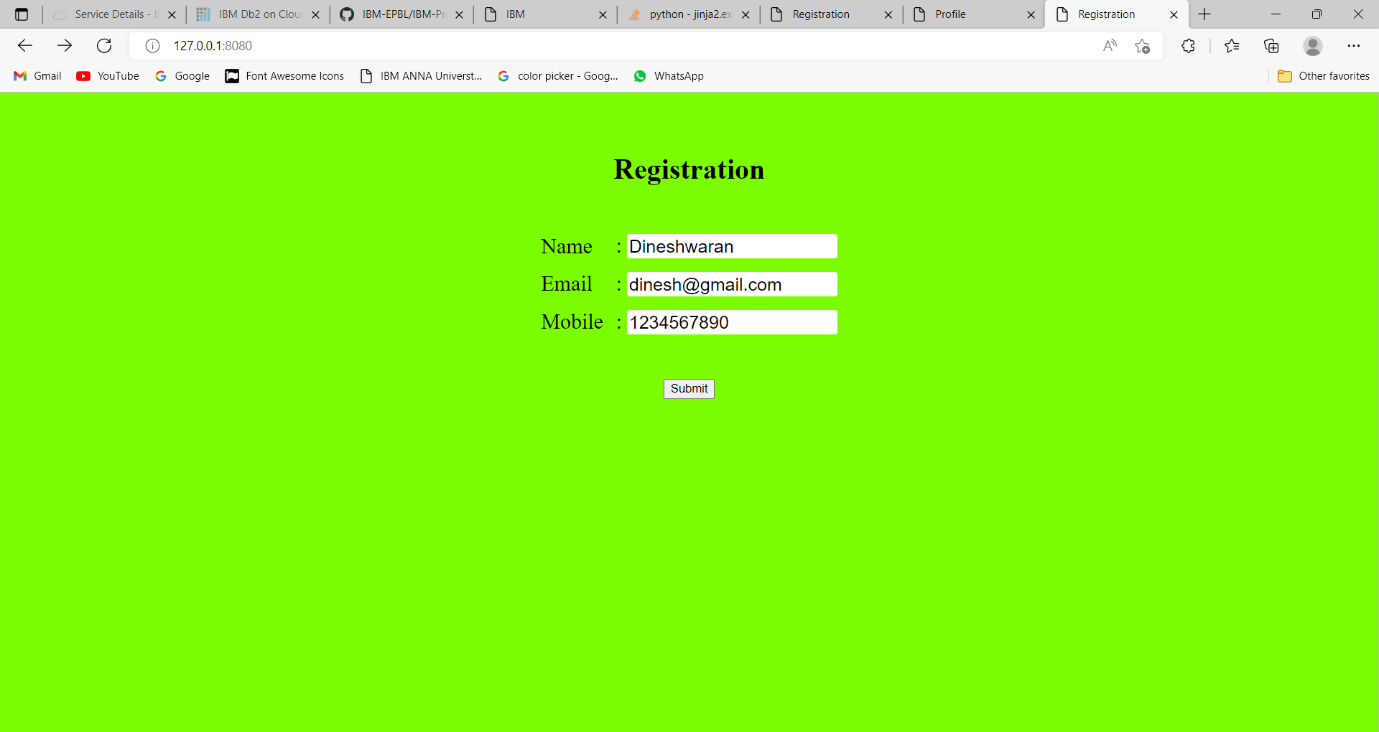

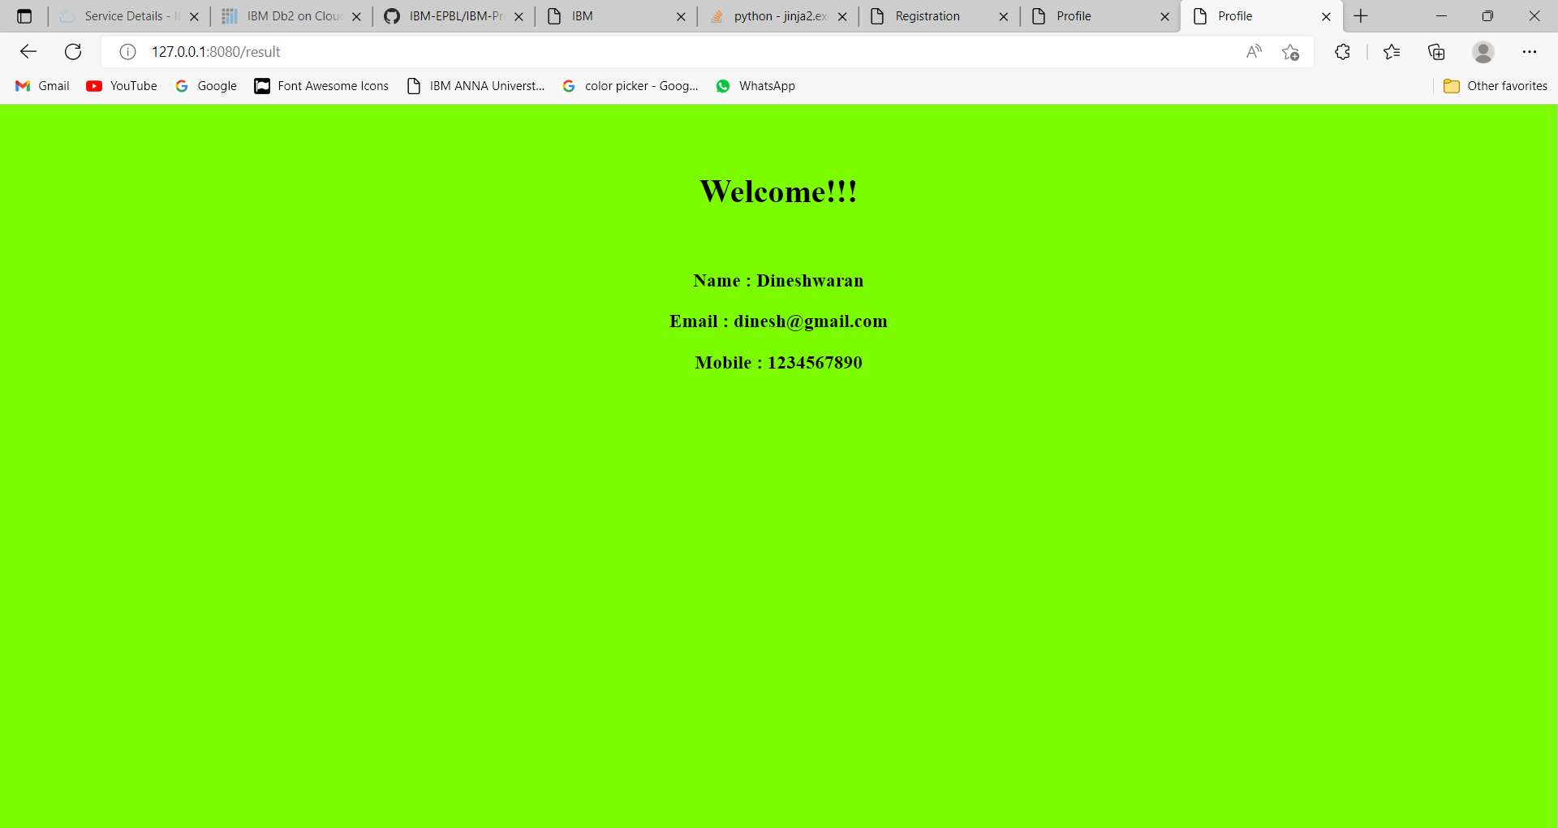

**Question-2:**

With a given integral number n, write a program to generate a dictionary that contains (i, i*i) such that is an integral number between 1 and n (both included). and then the program should print the dictionary.

Suppose the following input is supplied to the program:

8

Then, the output should be:

{1: 1, 2: 4, 3: 9, 4: 16, 5: 25, 6: 36, 7: 49, 8: 64}

|  |
| --- |
| **Solution:** |
|  | n=int(input()) |
|  | d=dict() |
|  | for i in range(1,n+1): |
|  | d[i]=i*i |
|  |  |
|  | print d |
|  | #----------------------------------------# |
|  | #----------------------------------------# |

